How to use SEESAW – Pupil and Parent’s guide

Login to your own personal account following the instructions below;
HOW TO LOG INTO SEESAW
- Go to https://app.seesaw.me/on a computer or install the Seesaw Class App on an IOS device such as a tablet, ipad or phone.
- Choose “I’m a Student”.
- Type in the letters of your individual 12 digit code to access your Seesaw account for example ABCD ABCD ABCD:
Remember, this code is like a password – please keep it safe!
This screen should appear showing any activities that the teacher has set for you.
Click on the activity that you want to select and press add.
If this screen appears – select the drawing or note options;

Using the drawing option

if you click this icon. This screen appears 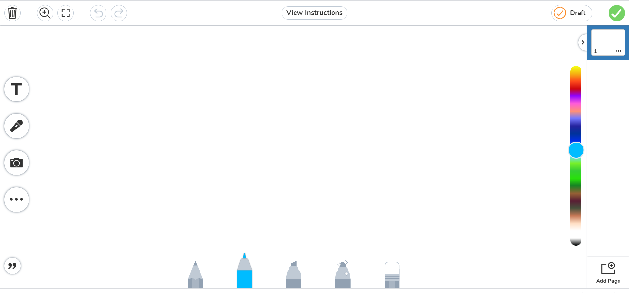
You can then click…. T icon. A text box will appear for you to add your own text and then drag the box to any position you want.

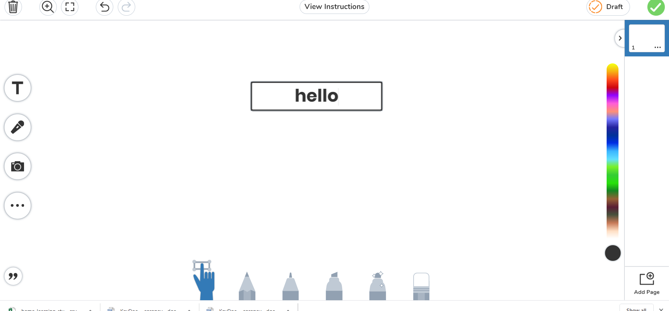

The pen/pencil options at the bottom, allow you to free-draw

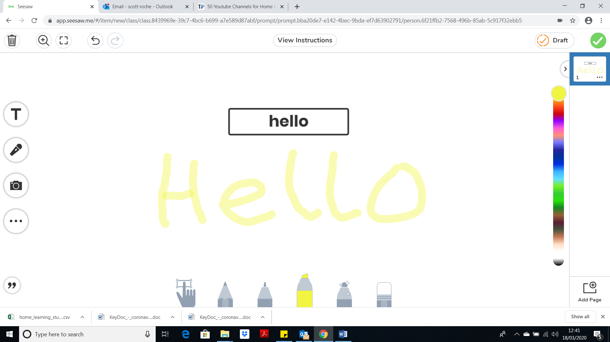

Using the notes option
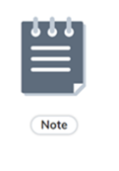Clicking this icon, lets you type to an exercise book

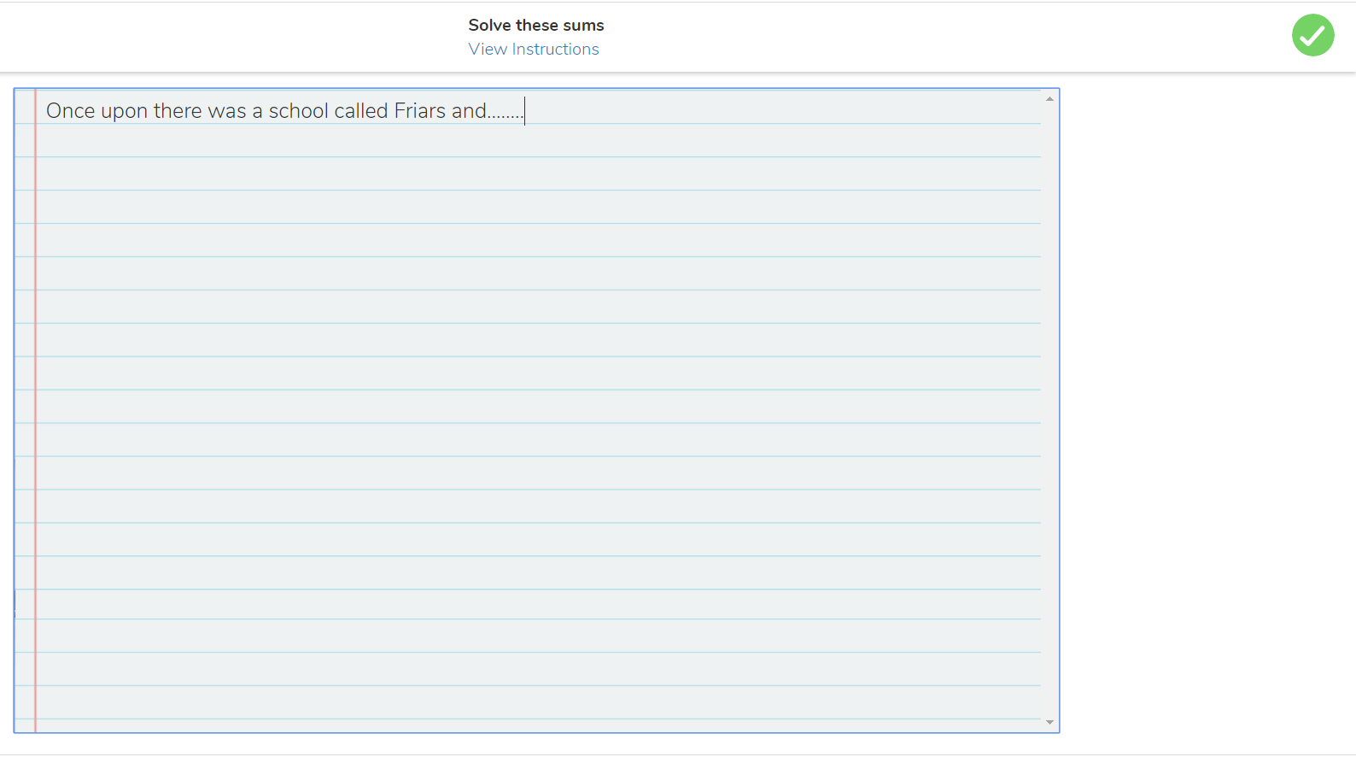

Saving your work
When you are ready to save your work for the teacher to see…..Click the green arrow in the top right hand corner of the screen
